SAANJHADELA FED FARMER PRODUCER COMPANY LIMITED
Block : Katoria, District: Banka(Bihar)
Introduction- Saanjhadela Fed Farmer Producer company was registered on 21/04/2021 under the Companies Act 2013. The company is mainly engaged in providing low cost quality agri-input like seed, seedling, fertilizer etc to the farmer, Training and ensurance of POP and market linkage of agriculture produce.
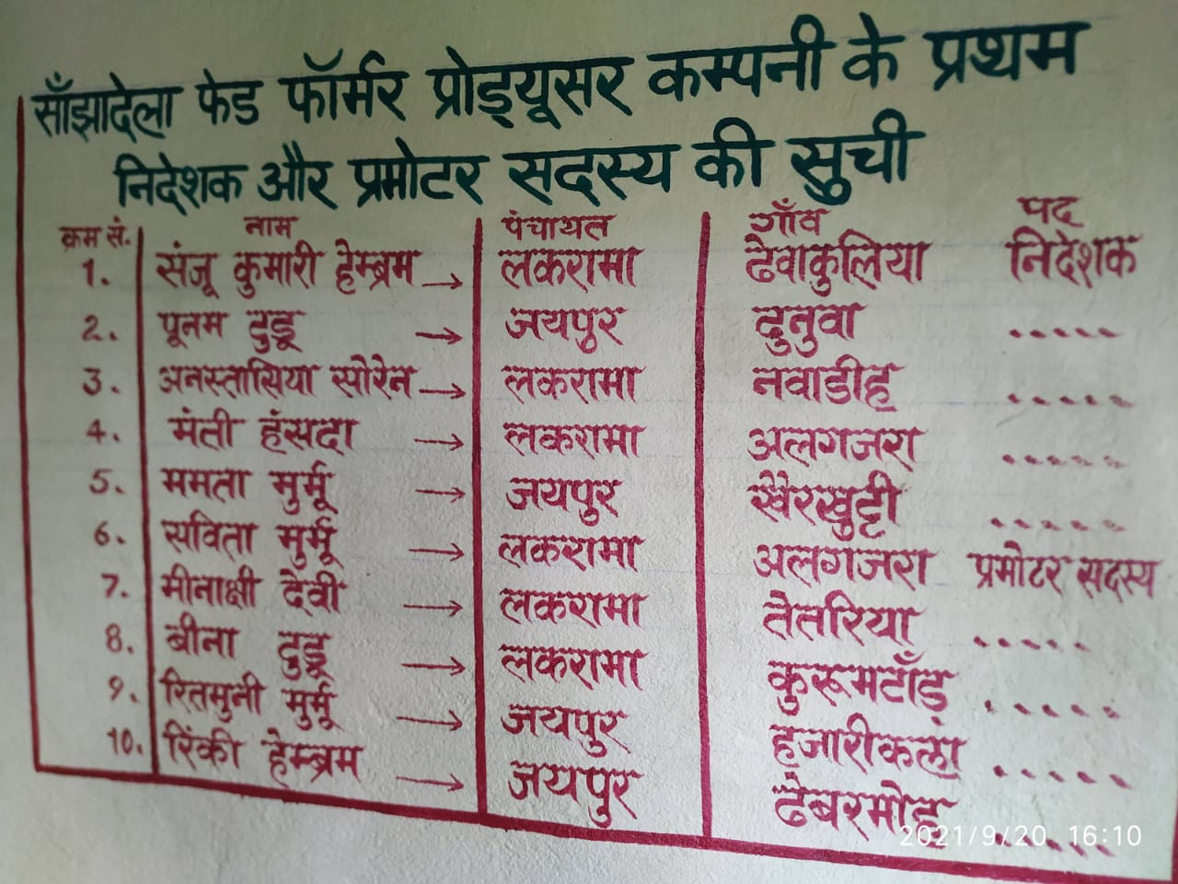
Director and Promoter of the company

Background
Currently F.P.O operates in 9 Panchayat of Katoria block, The total number of villages are 70.
The crops and produce company is mainly engaged in are as follows:-

S.No | Season | Crops | Produce
 | Kharif | - Tomato  - Brinjal  - Chilly  - Bitter gourd  - Bottle Gourd  - Cucumber  - Paddy  - Maize  - Pigeon pea  - Elephant Foot yam | - Tomato  - Brinjal  - Chilly  - Bitter Gourd  - Bottle Gourd  - Cucumber
 | Rabi | - Cauliflower  - Potato  - Mustard  - Frenchbean | - Cauliflower  - Frenchbean
 | Summer | - Watermelon  - Cucumber  - Bitter gourd | - Watermelon  - Cucumber  - Bitter gourd

Focus Areas
The company is mainly engaged in providing low cost quality agri-input like seed, seedling, fertilizer etc to the farmer, Training and ensurance of POP and market linkage of agriculture produce.

Strategic Interventions undertaken
To meet the purpose of FPO, the company has opted for following strategic interventions:

- Delievery of quality agri input at the doorstep of the farmers.
- Raising of quality seedling under the supervision of FPO and its linkage with the farmers.
- Promotion of Nursery entrepreneur in cluster who will raise and link quality seedling with the farmers under the supervision of company.
- POP training and crop monitoring with the help of agent of the company.
- Aggregation and market linkage of the produce.

Present Status-
INDICATORS/FPO
YEARS | April 2021-May 2022
NO. OF SHAREHOLDERS | 810
BUSINESS OUTREACH IN TERMS OF FAMILY | 2000
SHARE CAPIITAL MOBILIZED | 447000
INPUT TURNOVER | 120000
OUTPUT TURNOVER | 100000
PROFIT | 35000
PANCHAYAT | 9
LANDHOLDINGS (AVG) ACR | 2.5
VALUE ADDITION, BRANDING | sorting and grading
CREDIT LINKAGE | 0
WHAT SERVICES FPO WILL OFFER TO FARMERS | Planning, Training on POP of various crops, Input linkage and Aggregation and marketing of produce

Future Vision- The SAANJHADELA FED FARMER PRODUCER COMPANY (FPC) will improve the income of its farmer members from an average of Rs. 50,000 per annum per household to 60,000-80,000 per annum per household of 60% FPC farmers and more than 80,000 of rest 40% farmers in three years starting from 2021.
Mission- 1) Quality agri-input to the farmers.
2) Grooming and capacity building of farmers.
3) Farmer’s access to improved farm technology.
4) Aggregation and market linkage of farm produce
Plan for financial year 2022-2023 and 2023-2024 are as follows:
SAANJHADELA FED FARMER PRODUCER COMPANY LIMITED, KATORIA
INDICATORS/FPO
YEARS | 2022-2023 | 2023-2024
NO. OF SHAREHOLDERS | 2500 | 4000
BUSINESS OUTREACH IN TERMS OF FAMILY | 2500 | 4000
SHARE CAPIITAL MOBILIZED | 1250000 | 2000000
TURNOVER INPUT | 2000000 | 5000000
OUTPUT | 5000000 | 10000000
PROFIT | 210000 | 450000
PANCHAYAT | 9 | 10
VALUE ADDITION, BRANDING | sorting, grading and packaging | sorting, grading, packaging and branding
CREDIT LINKAGE | Bank | Bank and other financial institutions
WHAT SERVICES FPO WILL OFFER TO FARMERS | Planning, Training on POP of various crops, Quality Input, Market Linkage | Planning, Training on POP of various crops, Quality Input, Market Linkage
BUYER | Mandi and other big agri companies | Mandi and other big agri companies

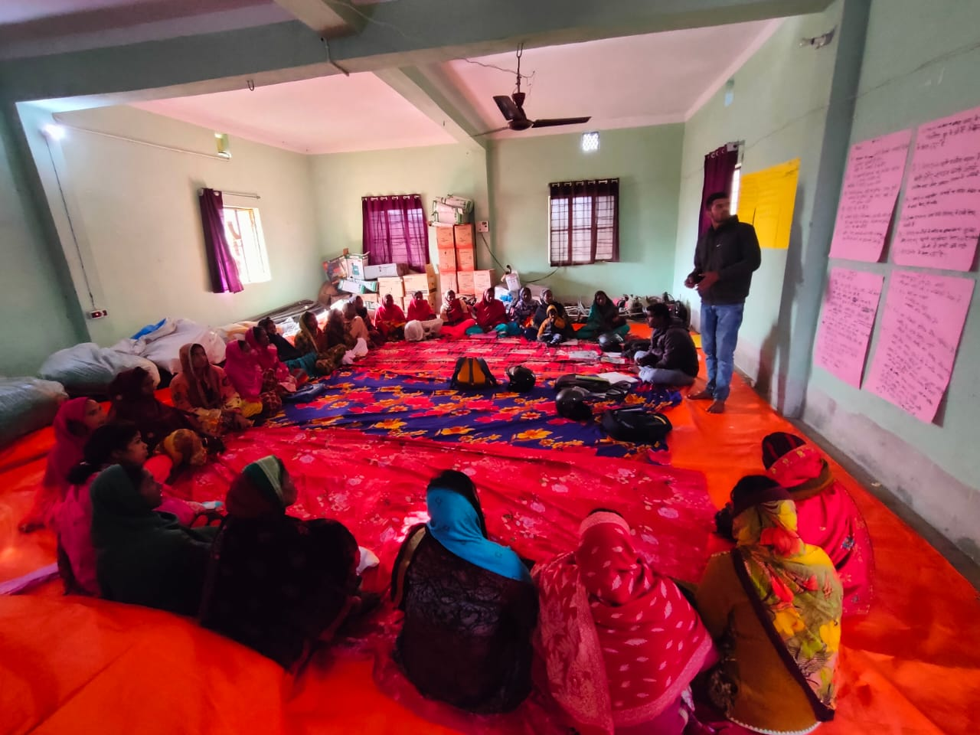
Grooming and training of P.G leaders
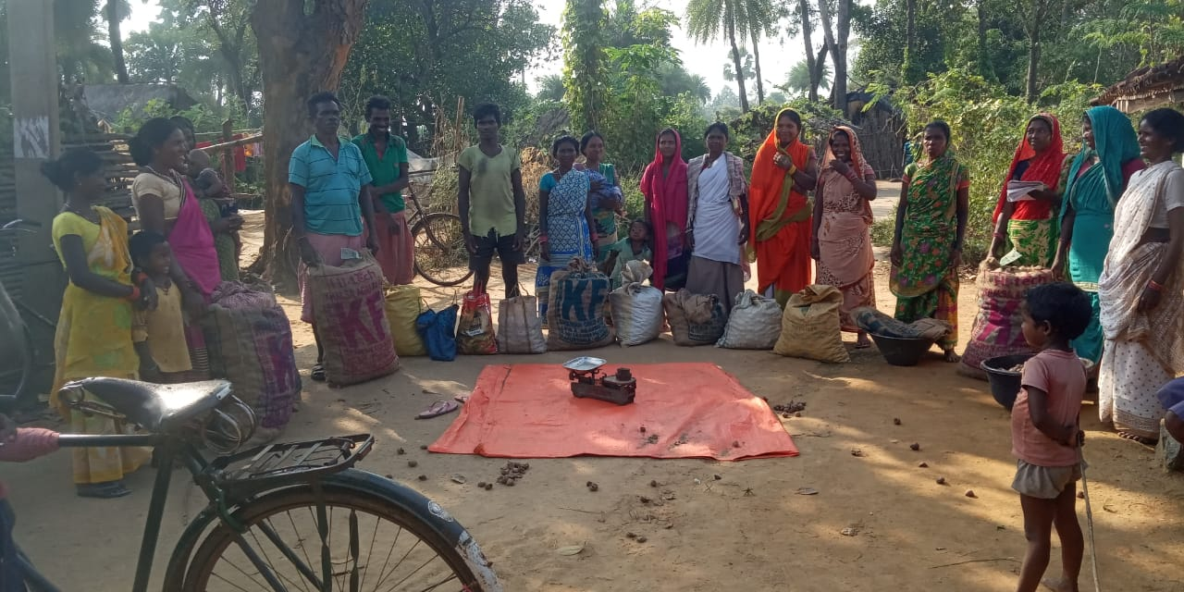
Potato linkage with the P.G members

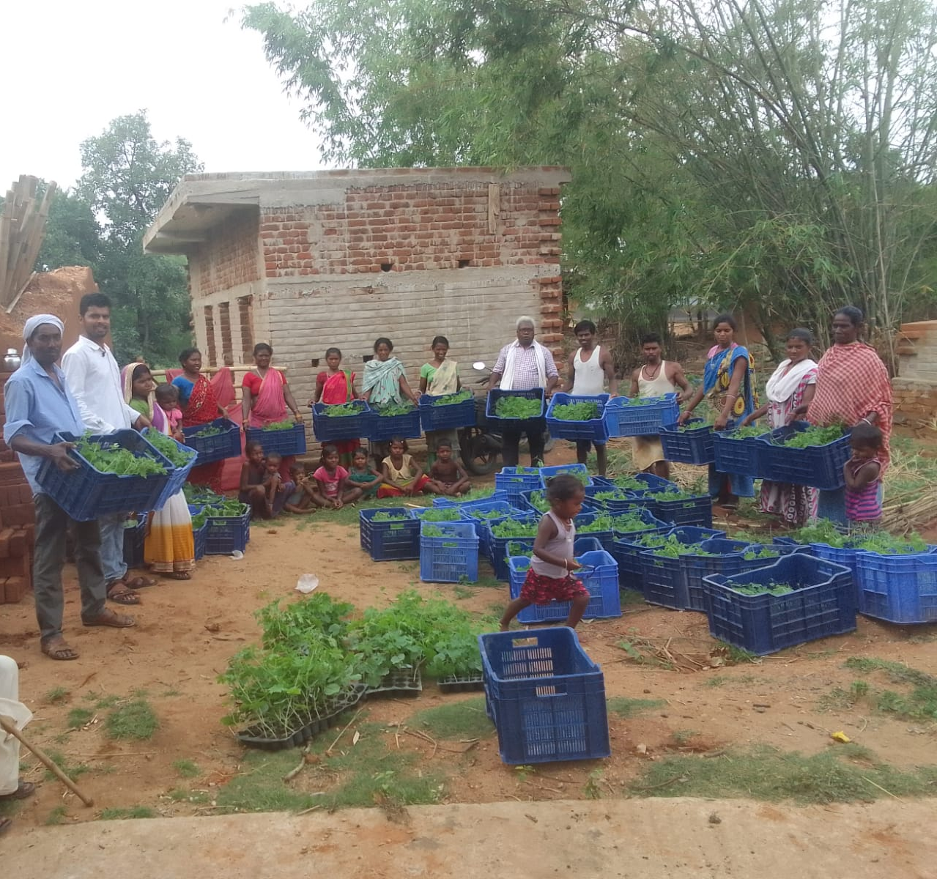
Seedling Linkage with the P.G farmers
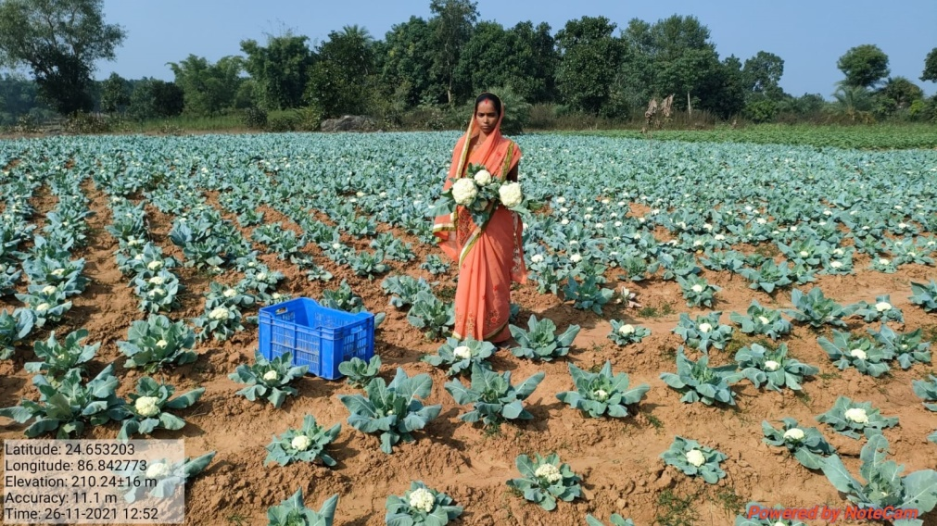
Cauliflower in field

Name and Contact Number
- Chairman BoD, FPO:
Sanju Hembram :- 7632942798

- CEO, FPO:
Sahil Akthar :- 6203603031

- CBBO Point of contact:
Ayush Kumar :- 7004850641

