Terms & Conditions for auction to be held through NAFED Guwahati branch for supply of Masur Dal Unsplit (Small) to State Government of Mizoram under ICDS.

NAFED, Guwahati Branch invites financial bids from the eligible millers/traders for supply of processed pulses to Government of Mizoram under ICDS. Interested bidder(s) may submit their bid(s) as per details given below.

Name of Government Institution | Directorate of Women & Child Development, Government of Mizoram
Commodities to be supplied | Masur Dal unsplit (small)
Delivery locations | District wise delivery (As per annexure II)
Pack size | 25 Kg PP Bag
EMD & SD | EMD – 2% of the total estimated contract value SD – 5% of the total estimated contract value
Delivery Period | 2nd Qtr, 2025-26
Delivery timelines
Submission of SD by the successful bidder | Within 05 bank working days from date of issue of award/work order by NAFED to the successful bidder.
Due date for completion of delivery | 100% of awarded quantity will be completed on or before 31st Dec 2025.
Auction rules
Bidding parameter | Price bid in Rs. per quintal including cost of procurement of required pulses, applicable GST, other statutory dues, taxes, loading & unloading charges, labour charges, transportation and all other related charges for delivery of commodities to specified locations.
Bid Validity | 30 calendar days or acceptance of rate by state  department whichever is later
Process of Bidding Submission | Submission of password protected PDF files over e-mail latest by 30.10.25 till 02:00 PM. Bids received beyond the time frame are subject to rejection. Bids will be opened on 30.10.25 at 03.00 PM in presence of the bidders.

Note:

NAFED reserves its right to accept or reject any or all the bids without assigning any reason thereof.
- This bid document shall be governed and construed in accordance with the Indian Laws.
- It may kindly be noted that Government of India or any State Government in India shall not be a party to this transaction.
- No Suit, prosecution or any legal proceedings will be lie against NAFED or any official(s) of NAFED for anything that is done in good faith or intended to be done in pursuance of supply under this bid documents/auctions.

GENERAL TERMS AND CONDITIONS

Eligibility criteria of Miller(s)/trader(s) for participation in bid
Bids are invited from Miller(s)/trader(s) meeting following eligibility criteria.
  - Bidder(s) should be manufacturer or trader of pulses.
  - In case of manufacturers, the bidder should have valid FSSAI license for manufacturing, storing and packing of pulses.
  - In case of trader, the bidder should have valid FSSAI license for trading of pulses.
  - Successful bidder, after completion of auction, shall submit valid proofs of FSSAI license, GST registration, address proof, PAN and any other document as required by NAFED through email at nafguw@nafed-india.com.

Quality Parameters of Pulses to be Supplied
  - The successful bidder shall confirm to the relevant quality specification mentioned as per Annexure 1 of this bid documents. Quality parameters other than parameters mentioned in Annexure1, shall be in accordance with the specifications indicated in the latest applicable Food Safety and Standards Act and connected rules. Supplied Pulses must be free from common deleterious matter. The pulses stock should be free from adulteration.
  - NAFED and/or authorized official from State Level Agency at its own discretion may get samples tested for added color/adulteration. The Cost of such test will be debited to miller’s/trader’s account. Action will be initiated against those millers/traders who fail to comply with above specified quality parameters as per terms and conditions, and as per provisions under Food Safety and Standards Act 2006 and connected rules.
  - The successful bidder will be solely responsible for consequences for any violation of the latest applicable Food Safety and Standards Act and connected rules.

Packaging & Labeling

  - Successful bidder should supply the stock of processed pulses as per the quality parameters defined in annexure I of this document in pack size of 25 Kg of good quality of PP Bag
  - The pack design to be printed on packaging material shall be provided to successful bidder along with award letter.
  - The successful bidder shall take all necessary action to commence the packaging, assaying, dispatch and delivery of the awarded quantity of Pulses strictly as per quality specifications & other Terms & conditions of this bid documents and letter of award issued by NAFED in f/o successful bidder.
  - Successful bidder shall be required to supply the entire quantity as intimated by the NAFED Within the stipulated delivery period mentioned in this bid documents.
  - Successful bidder shall take adequate precautions to prevent damage or deterioration of Pulses during packing, handling, storage and transportation process.
  - Successful bidder shall be responsible and liable for any shortage, damages or deterioration of

Pulses during packing, handling, storage and transportation process till delivery at the designated stores.
  - If the packaging of Pulses stock is not as per requirement and any other defect found in necessary printed work etc. as per the packaged commodity Act and other rules applicable, the NAFED may initiate legal proceedings against the successful bidder or may terminate the contract as may be deemed proper by the NAFED.
  - Each bag should be double stitched by machines and should not be damaged or having any perforations of any kind or marks of re-stitching etc. there should not be any other marking other than details mentioned in the tender document.
  - Successful bidder shall be liable to obtain original acknowledgement for satisfactory receipt of entire awarded quantity in good condition from the concerned officials of State department.
  - Quantity of Pulses as per acknowledgment given by State department shall be final and binding on successful bidder and payment to successful bidder shall be paid accordingly after receipt of payment from concerned department of State Govt.

Assaying &Testing
  - Successful bidder shall ensure that the quality specifications of the supplied Pulses are strictly in accordance with the terms and conditions of this contract.
  - The quality of the pulses will be tested at the delivery location as per the given specification.
  - Failure to comply with the required quality parameters will result in re-supply of pulses within 5 calendar days or period as desired by State Govt.
  - In the event of rejection of quality of supplied Pulses at designated delivery stores, successful bidder shall be wholly and solely responsible for lifting of such stock at their own cost and risk within 05 calendar days from date of rejection or as desired by State Govt.
  - NAFED may reject the supply in whole or in part if supplies not found in accordance with this quality specifications mentioned in this contract note.
  - NAFED will not be responsible in any way for rejection of stock at any point of time during delivery till receipt of satisfactory confirmation from State department. The supplier must provide at least 6 months comprehensive warranty of the product.
  - In case, any quality related complaint arises during the warranty period, supplier has to replace the same failing which the party may be blacklisted.

Warranty
Successful bidder has to ensure that processed dal delivered to State adheres to quality specifications as per contract with a minimum shelf life of 6 months from date of supply. In the event, the stock is found not-conforming to the mentioned quality parameters anytime during period of 6 months from date of supply, the successful bidder shall be liable to replace the same at its own cost & risk.

Delivery process
  - The successful bidder shall take all necessary steps to commence the packing, assaying, and dispatch of the entire contracted quantity at the approved rate and complete the delivery to the designated delivery depots as specified by the NAFED/ Institutional Client latest by due date mentioned in this contract note / award letter to be issued by NAFED.
  - Immediately after approval of auction, the successful bidder shall have to submit a daily dispatch plan to NAFED Guwahati Office.

    - The dispatch plan has to be submitted from date of award to due date of delivery. The successful bidder shall have to plan consistent dispatch on a daily basis.
    - NAFED shall review the dispatch plan submitted by the successful bidder and may modify the same in consultation with the successful bidder.
    - Successful bidder’s performance shall be monitored & reviewed by NAFED authorities. In the event successful bidder fails to perform as per the dispatch plan agreed by the successful bidder as well as NAFED, NAFED, at its sole discretion, may cancel the contract for balance quantity and relist the auctions, at cost & risk of the successful bidder.
  - The successful bidder should take adequate precautions to prevent damage or deterioration of stock during storage/transportation. He should also insure the stock during transit at his cost.
  - Consignment will be unloaded at the designated warehouse during working hours i.e. between 10 AM and 5 PM only. On arrival of the consignment, official(s) nominated by the State will verify the documents and after confirming authenticity of the consignment may direct the representative of the supplier to arrange for recording the gross weight of the consignment on an electronic weigh bridge before unloading.
  - The copy of invoice / delivery Challan shall be handed over to designated official at the time of giving delivery. Deliveries without valid documents will be rejected and will not be inwarded by the concerned Depot Manager.
  - Quantities supplied in excess of the quantity specified in the purchase order will not be paid for Institutional client/ NAFED reserves right to revise quantities awarded by ±25% or may terminate the contract for any month or in total. State Govt./NAFED is not liable to present any reasons for any actions thereof and will not bear any financial liability arising due to cancellation by state etc.

Submission of bids
  - The bidder has to bid for Price in Rs. per quintal including cost of procurement of pulses, applicable GST, other statutory dues, taxes, loading & unloading charges, labour charges, transportation and all other related charges for delivery of commodities to specified location.
  - NAFED reserves the right to accept or reject any or all the bid(s) without assigning any reason thereof.
  - NAFED shall not be responsible for any mistake done by the bidder in punching the bids during the time of auction. In case of punching the wrong bid, an amount @25% of EMD amount will be retained by NAFED and balance will be released to party.
  - The winning bid will remain valid for 30 calendar days from date of bid submission or acceptance of rate by state department whichever is later.
  - Bids received for partial quantity shall be liable for rejection.

Billing, Payment and Penalty
  - Successful bidder shall raise sale invoices in favour of NAFED Guwahati.
  - It is hereby agreed by the successful bidder that NAFED shall pay to the successful bidder and the successful bidder shall be entitled to receive from NAFED, for the supply of Pulses to State Govt. of Mizoram, a charge equal to actual net quantity of Pulses delivered to State Govt. of Mizoram multiplied by the supply rate quoted as per the bid offered by the successful bidder in this bidding process on the electronic portal after deducting claims for weight shortages, rejected quantities or any other deductions due to any reason whatsoever, if any made by the NAFED Guwahati.
  - All the payments shall be made based on receipt of bills, after successful completion of a supply contract and receipt of payment from State Govt. Such payments are subject to TDS as per the IT rules.

EMD and Security Deposit

  - Interested bidder must deposit EMD of amount equivalent to 2% of the estimated total contract value before participation in the bidding process. EMD (without any interest) of the unsuccessful bidders of the contract shall be returned immediately on closure of bidding.
  - The EMD amount must be deposited to NAFED Guwahati Branch Bank Account through NEFT/RTGS, well within the stipulated time of submission of bids. The bank account details of NAFED Guwahati Branch are as below:

Name | NAFED
Bank Name | HDFC BANK
A/c No. | 50100487139189
IFSC Code | HDFC0000631

  - EMD of the Successful bidder would be retained by NAFED and shall be refunded after submission of security deposit of amount equivalent to 5% of contract value calculated on the basis of quoted supply price by the successful bidder. The successful bidder may opt to convert the EMD amount to required security deposit and submit remaining security deposit directly with dealing NAFED branch in form of Bank guarantee (in favour of NAFED) from any scheduled bank/nationalized bank or through NEFT/RTGS to NAFED.
  - In the event of a delayed supply, security deposit of the successful bidder will be returned after recovery of LD charges or other deductions applicable due to any reason whatsoever.
  - If successful bidder fails to deposit SD amount within given time period, EMD deposited by the successful bidder at the time of bidding, shall be forfeited by NAFED without giving any written notice. In such eventuality, NAFED reserves the right to cancel/ reject the bids at the cost and risk of the successful bidder.
- The security deposit of the successful bidder shall also be forfeited/adjusted by NAFED without giving any written notice under following circumstances:
  - Non-completion of the contract by the successful bidder.
  - Non-payment of penalty charges, penal storage rent or any other dues to UT Institution and/or NAFED.
  - Deviation to the any terms and conditions of this contract note during supply period.
- The EMD and SD deposited by the successful bidder shall carry no interest and refunded to the successful bidder after completion of successful deliveries and receipt of payments from the concerned government department to NAFED. Penalties/ deduction, if any deducted by the buyer shall be recovered from the successful bidder

Penalty & LD clauses
  - Penalties as levied by the State Dept. due to any reason whatsoever shall be recovered from the suppliers on actual basis.

Other Terms and Condition
  - The bidder will have to undertake the work on their own they cannot sub-contract to any third party.
  - The successful bidder to ensure compliance of PF/ESI laws in respect of employees involved in processing of stock. Proof of deposit of PF/ESI is required to be submitted by the successful bidder at the time of submission of invoice to NAFED. NAFED will not be responsible for any non- compliance of PF/ESI laws by the successful bidder.

Acceptance of terms and conditions

  - By submitting the tender fees and/or EMD, the bidder confirms that the bidder has read and agrees to all the terms and conditions mentioned in this contract as well as the empanelment agreement executed with NAFED along with all the corrigendum / addendum if any.
  - The successful bidder shall submit a stamped and signed copy of this document in original along with the Security Deposit to the State Head of the concerned branch of NAFED.
  - The successful bidder shall submit a stamped and signed copy of this document in original to the State Head of NAFED Guwahati.

Taxes applicable
  - All the transactions under this contract shall be subject to applicable taxes as per the governing laws.

Interpretation of the clauses in this tender documents
In case of any ambiguity/ dispute in the interpretation of any of the clauses in this tender document, NAFED’s interpretation of the clauses shall be final and binding on bidder.

Resolution of Dispute
NAFED and the successful bidder shall make every effort to resolve mutually by direct informal discussions and negotiations, any disagreement or dispute arising between them under or in connection with this contract. If after thirty days from the commencement of such informal discussions and negotiations, NAFED and the successful bidder have been unable to resolve the disputes mutually, such disputes will be adjudicated and resolved in a Court of law in Delhi. This Contract shall be governed by the Laws of India for the time being in force. The dispute mechanism shall be as per Arbitration conciliation Act of 1996 and venue & seat of arbitration shall be at New Delhi.

Force Majeure
  - If at any time during the existence of this tender documents either party is unable to perform in whole or in part any obligations under this bid documents document because of war, hostility, military operations, civil commotion, sabotage, quarantine, restrictions, acts of God and acts of Government (including but not restricted to prohibitions of exports and imports), fires, floods, explosions , epidemics, strikes or any other labour trouble, embargoes, then the date of fulfillment of any obligations engagement shall be postponed during the time when such circumstances are operative . Any waiver/extension of time in respect of the delivery of any installment or part of the goods shall not be deemed to be waiver/extension of time in respect of the remaining deliveries.
  - If operation of such circumstances exceeds three months either party will have the right to refuse further performance of the contract in which case neither party shall have the right to claim eventual damages.
  - The party which is unable to fulfill its obligations under the present contract must within 15 days of occurrence of any of the causes mentioned in this clause shall inform the other party of the existence or termination of the circumstances preventing the performance of the contract. Certificate issued by the competent authority connected with the case India shall be sufficient proof of the existence of the above circumstances and their duration. Non-availability of raw material will not be an excuse to the successful bidder for not performing their obligation under the contract.

Defaults
If the successful bidder refuses or fails to make deliveries of the goods conforming to the contracted specification within the time specified or to perform faithfully any contractual terms, the NAFED may, without prejudice to other rights of the NAFED resulting from breach of the contractual terms, by given written notice cancel or rescind the contract or terminate the right of the Supplier to proceed with any or all of the remaining part under the contract to be performed. In such eventuality NAFED shall forfeit the Security deposit amount submitted by the supplier at the time of bidding without giving any written notice.

Indemnification
The successful bidder shall indemnify NAFED and keep indemnified against any loss or damage, claims, compensation, penalty, fine, levies, etc. on account of slackness, deficiency, failure to observe any obligations under the contract, failure to comply with statutory/ mandatory provisions pertaining to the contract.

Damages
If the goods are not delivered within the due date of delivery, the successful bidder shall be liable to pay to NAFED on demand without any question whatsoever, damages on account of extra expenditure, loss of revenue and loss of other benefits to the NAFED. The quantum of such damages will be determined at the sole discretion of NAFED.

General Provisions
- Governing Laws: This contract will be governed and construed in accordance with the laws of the republic of India without giving effects to the principles of conflicts of laws. Both parties agreed to submit the jurisdiction at New Delhi and further agreed that any cause of action arising under this contract may be brought in a court at New Delhi.
- Compliance with Laws, Notifications etc. : Supplier confirms that it has entered into this transaction with the full knowledge and understanding of this Contract and subject to all the laws and notifications and rules applicable to this area, including terms and conditions laid down by the Government of India or any State Govt. and the undertakings given by the NAFED to the Competent Authority of the Government of India in this regard and that the Supplier has familiarized itself with all the aforesaid and other applicable contracts, arrangements, undertakings, conditions on inspection of the documents with the NAFED.
- Further Assurances: The parties hereto shall cooperate with each other, both during and after the term of this contract, and to execute, when requested, any other document deemed necessary or appropriate by parties hereto to carry out the purpose of this contract.
- Severability: If any provision of this contract is held to be invalid or enforceable for any reason, the remaining provisions will continue in full force without being impaired or invalidated in any way. The parties hereto agree to replace any invalid provision with a valid provision which most closely approximates the intent and economic effect of the invalid provision.

- Waiver: Nota limitation to enforce
  - Failure of either party to enforce at any time or for any period of time the provisions hereof shall not be construed to be waiver of any provisions or of the right thereof to enforce each and every provision.
  - Any express or implied waiver by the NAFED of any default shall not constitute a waiver of any other default by the 'Supplier or a waiver of any of the NAFED rights. All original rights and powers of the NAFED under this Contract will remain in full force, notwithstanding any neglect, forbearance or delay in the enforcement thereof by the NAFED, and the NAFED shall not be deemed to have waived any of its rights, or any provision of this Contract, or any notice given hereunder, unless such waiver be provided in writing by NAFED, and any waiver by the NAFED of any breach by the Supplier of the Contract, shall not be deemed a waiver of any continuing or recurring breach by the 'Supplier of the Contract.
- No Assignment: Neither party may assign or transfer its rights or obligations under this contract without the prior written consent of the other party, and any assignment or transfer in derogations of the foregoing shall be null and void, provided, that either party shall have the right to assign the contract, without the prior written consent of the party, to the successor entity in the event of merger, corporate re-organization or sale of all or substantially all of its assets. The terms of this contract shall be binding upon such assignees.
- Right to amend terms and conditions:
  - The Supplier agrees and understands that terms and conditions of the Contract may be modified/amended by the NAFED in accordance with any directions/order of any court of law, Governmental Authority, in compliance with applicable law and such amendment shall be binding on the 'Procuring Society.
  - The NAFED further reserves the right to correct, modify, amend or change all the Schedules attached to this Contract and also Schedules and/or Annexure which are indicated to be tentative at any time or addendum to this contract, if any, executed between the parties.
- Notice: Any notices required or permitted herein under shall be given to the appropriate party at the address specifies herein or as such other address as the party shall specify in writing. Such notice shall be deemed given: upon personal delivery; if sent by the facsimile, upon confirmation of receipt; or if sent by certified by or registered mail postage etc. 7 days after the date of mailing.
- Entire Contract: This contract together all annexure, specifications and other attachments which are incorporated herein by reference, is the sole and entire contract between the parties relating to the subject matter hereof. This contract supersedes all prior understandings, contracts and documentation relating to such subject matter. No supplement, modification or amendments of this contract shall be binding unless executed in writing by both parties in this contract. In the event of conflict of provisions of the main body of the contract and attached annexure, specification or other materials, this contract shall take precedence.

Applicable Law, Jurisdiction and Dispute Resolution:
- This document shall be constituted and the legal relation between the parties hereto shall be determined and governed according to the laws of Republic of India and only courts at High Court
of Delhi shall have the jurisdiction in all matters arising out of /touching and/or concerning this contract and parties to this contract agree to irrevocably submit to the exclusive jurisdiction of those courts for purposes of any such proceeding. The aforementioned exclusive and irrevocable jurisdictions of aforesaid courts are irrespective of place of occurrence of any cause of action pertaining to any dispute between the parties.

- All or any disputes arising out or touching upon or in relation to the terms of this contract including the interpretation and validity of the terms thereof and the respective rights and obligations of the parties shall be settled amicably by mutual discussion failing which the same shall be settled through arbitration. The arbitration proceedings shall be governed by the Arbitration and Conciliation Act of 1996 (as amended up to date) or any statutory amendments/modifications thereof for the time being in force. The seat and venue of the arbitration shall be at New Delhi India and language of arbitration shall be English.

Nothing contained in this clause shall prevent the NAFED from seeking interim injunctive relief against the Supplier in the courts having jurisdiction over the parties.

NOTICE OF DISCLAIMER
- The information contained in this contract note or subsequently provided to intending Applicant(s) whether verbally or in documentary form by or on behalf of National Agricultural Cooperative Marketing Federation of India Ltd. (NAFED) or any of its employees or officers (referred to as “NAFED Representative”) is provided on the terms and conditions set out in this contract note document and all other terms and conditions subject to which such information is provided.
- No part of this contract note and no part of any subsequent correspondence by NAFED, or NAFED Representatives shall be taken neither as providing legal, financial or other advice nor as establishing a contract or contractual obligations. Contractual obligations would arise only if and when definitive agreements have been approved and executed by the appropriate parties having the authority to enter into and approve such agreements.
- The contract note document has been prepared solely to assist prospective Applicants in making their decision to get empaneled with NAFED. NAFED does not purport this information to be all - inclusive or to contain all the information that a prospective Applicant may need to consider in order to submit a bid. The data and any other information wherever provided in this contract note is only indicative and neither NAFED, nor NAFED Representatives, will make or will be deemed to have made any current or future representative, promise or warranty, express or implied as to the accuracy, reliability or completeness or the information contained herein or in any document or information, whether written or oral, made available to a Applicant, whether or not the aforesaid parties know or should have known of any errors or omissions or were responsible for its inclusion in or omission from this contract note.
- Neither NAFED nor NAFED Representatives make any claim or give any assurance as to the accuracy or completeness of the information provided in this contract note Document. Interested parties are advised to carry out their own investigations and analysis or any information contained or referred to herein or made available at any stage in the bidding process in relation to the Project. Applicants have to undertake their own studies and provide their bids.
- This contract note Documents is provided for information purposes only and upon the express understanding that such parties will use it only for the purpose set forth above. It does not purport to be all-inclusive or contain all the information about the Project in relation to which it is being issued.
- The information and statements made in this contract note document have been made in good faith. Interested parties should rely on their own judgments in participating in the said Project. Any liability is accordingly expressly disclaimed even if any loss or damage is caused by any act or omission on part of the aforesaid, whether negligent or otherwise.

- The contract note Document has not been filed, or approved in any jurisdiction. Recipients of this document should inform themselves of and observe any applicable legal requirements. NAFED makes no representation or warranty and shall incur no liability under any law, statute, rules or regulations as to the accuracy, reliability or completeness of the contract note Document.
- NAFED reserves the right to reject all or any of the application submitted in response to this contract note at any stage without assigning any reasons whatsoever.
- All Applicants are responsible for all costs incurred by them when evaluating and responding to this document and any negotiation costs incurred by the recipient thereafter. NAFED may in its sole discretion proceed in the matter it deems appropriate which may include deviation from its expected evaluation process, the waiver of any documents and the request for additional
information. Unsuccessful Applicants will have no claim whatsoever against neither NAFED nor its employees, officers.
- NAFED reserves the right to modify, suspend, change or supplements this contract note at any stage. Any change to the contract note will be notified to all the Applicants to whom the contract note is issued.
- Mere submission of a Bid does not ensure selection of the Applicant as Successful Applicant or Operator.

PREVENTION OF FRAUD AND CORRUPTION
- The Supplier shall be bound to take all measures necessary to prevent Fraud and Corruption while dealing with NAFED. Supplier agree and undertake to observe the principles/ provisions as laid down in “Holiday Listing Policy” of NAFED during their participation in the tender process, during the execution of contract and in any other transaction with NAFED.
- The Supplier shall not, directly or through any other person or firm, offer, promise or give or otherwise allow any of NAFED’s employees any material or other benefit which he/she is not legally entitled to, in order to obtain in exchange any advantage of any kind whatsoever during the tender process or during the execution of the contract.
- The Supplier shall not enter with other supplier into any undisclosed agreement or understanding, whether formal or informal. This applies in particular to prices, specifications, certifications, subsidiary contracts, submission or non-submission of bids or any other actions to restrict competitiveness or to introduce cartelization in the import process.
- The Supplier shall not commit or allow any employees of NAFED to commit any offence under the relevant provisions of IPC/Prevention of Corruption Act; further the Supplier will not use improperly or allow any employee(s) of NAFED, for purposes of competition or personal gain, or pass onto others, any information or document provided by NAFED as per of the business relationship, including information contained or transmitted electronically.
- The Supplier shall not instigate third persons to commit offences/activities outlined in Fraud Prevention Policy or be an accessory to such offences.
- The Supplier if in possession of any information regarding fraud/suspected fraud, here by agree and undertake to inform NAFED of same without any delay.

Holiday Listing
  - NAFED’s policy for Holiday-Listing, which is available on the website of NAFED must be acceptable to the bidders. Notwithstanding anything contained in this Agreement, NAFED’s Policy of Holiday Listing is mutatis mutandis applies to this and in the event, the agency(s) while discharging its obligations under this tender/Agreement or otherwise, come(s) within the ambit of the said policy, NAFED at its sole discretion reserves the right to suspend/discontinue dealings or take any curative measures with agency (s) in accordance with the policy in force.

Integrity Pact

The bidder/supplier shall have to enter into an Integrity Pact with NAFED as per the attached format.

DECLARATIONS AND UNDERTAKINGS:

The bidder/supplier shall have to submit declarations while submitting their applications on the letter head of their entity(ies) as per the attached format.

For NAFED (Guwahati Branch)

Annexure I Quality specification

1. Masur Dal unsplit (Small)
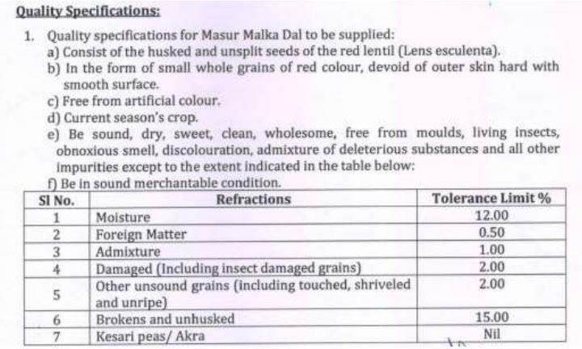

Annexure II Delivery Location

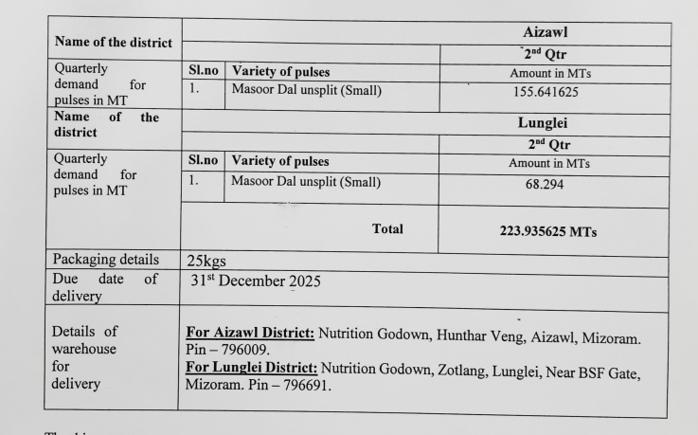

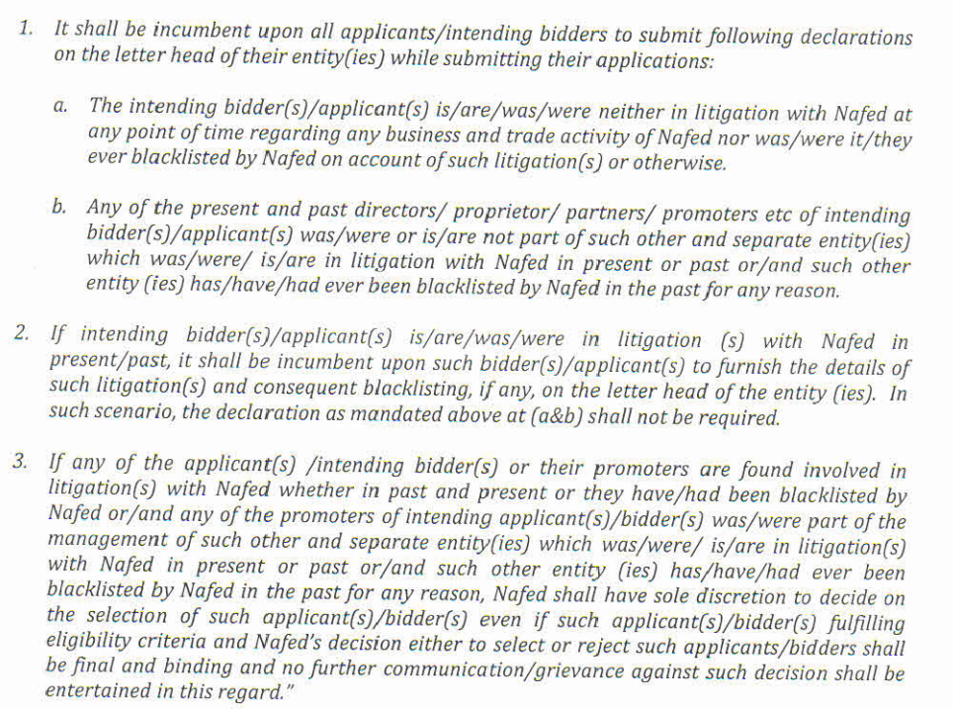
Annexure-III (to be submitted on the letter head with sign & seal)

