Laxminarayana Swamy Jainath FED FarmerProducer Company Limited
Laxminarayana Swamy Jainath FEDFarmer Producer Company Limited promoted by Grant Thornton Bharat LLPand NAFED is working with the main objective to provide member farmers with better market access opportunities. The FPO is located in Jainath Village, JainathMandal, Adilabad District, Telangana.

Year of Registration | 08-04-2021
State | Telangana
District | Adilabad
Block | Jainath
CBBO | Grant Thornton Bharat LLP
Shareholder Farmers (Nos)
 | Small Farmers: 101 Marginal Farmers: 239
 | Women Farmers: 41 Tribal Farmers: 0
State Category | Plain Area
Share Capital (INR- Lakh) | 4.10 Lakh
Business Activities (Summary) | 90 Lakhs Turnover (Seed, Fertilizer, Pesticides Sales)
Area of Success*: | Supply of Quality Agri Inputs, Access to Production and Post-Harvest Machinery, Market Linkages
Board of Directors | Male: 05 Female: 01

*Area of Success: Supply of Quality Agri Inputs, Access to Production and Post-Harvest Machinery, Access to Value Addition Facilities, Adoption of Higher Income Generation Activities, Access to Market Intelligence, Credit Linkages,Market Linkages, etc.

Background

The region is heavily dependent on agriculture with poor infrastructure facilities, intermediary involvement, lack of farm produce collectivization, lack of better price realization and challenges in access to market are some of the key challenges. Laxminarayana Swamy Jainath FED FPCL deals with produce like Soybean, Cotton and Bengal Gram.

Focus Areas

Identifying the need for market linkages and better price discovery, the FPC was formed in 08.04.2021. FPC has today has increased its outreach to 381 shareholder farmers covering 10 Panchayats.

Strategic Interventions undertaken

FPC aimed to achieve its objectives by using collectivization techniques and participation of the benefiting community, including rural farmers, and panchayat.

FPC is bringing to its member farmers the benefit of direct procurement from the market players inSoybean, Cotton and Bengal Gram. FPC has developed demand planning and forecasting system under the leadership of BODs.

FPC has established input shops for the farmers and provided inputs like Fertilizers,Pesticides High yielding seeds varieties and provided power tiller and tractor accessories to the farmers based on the demand.

Success Mantra

FPC with the support of CBBO has demonstrated the impact of collectivization of small and marginal farmers to leverage economies of scale in Production and marketing.

FPC done total business of Rs. 90Lakhs within the year of establishment benefiting 381 member farmers and 200 non-member farmers,

Increase in farmer incomes by 15%.

Tie up with ABYFarmers LLPfor organic farming and Vikrant Seed& Srinivas Agri Farms Private Limited.

Assured market linkage is helping farmers avoid distress sale in the hand of intermediaries and local market.

Recognition

FPC has shared the success story in the Regional Conference of FPOs and CBBOs held at Bangalore to highlight the progress of FPC.

Benefits of the scheme

FPC has availed matching equity grant of 3.0 Lakh under the “Central Sector Scheme for Formation and Promotion of 10,000 Farmer Producer Organizations (FPOs)” on 1st January 2022.

Convergence with other Central and State government schemes

FPC has not applied under any scheme until date. Looking for Collection centre from State Government

Lessons learnt

Direct sale to large buyers has helped reduce unnecessary involvement of the intermediaries in the process and the farmers are getting good prices for their produces. The FPO model is creating huge improvement in socio-economic conditions of small and marginal farmers with their increasing participation in the decision making thus making them empowered

ix. Way forward

Going forward the FPC to diversify into value added products and set up a processing plant under AIF (Agriculture Infrastructure Fund) and avail Credit

High Quality Imageswith caption

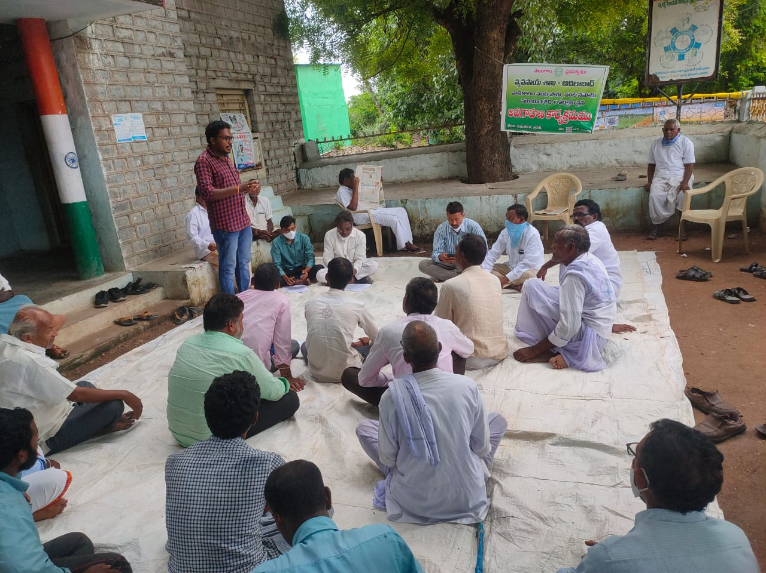

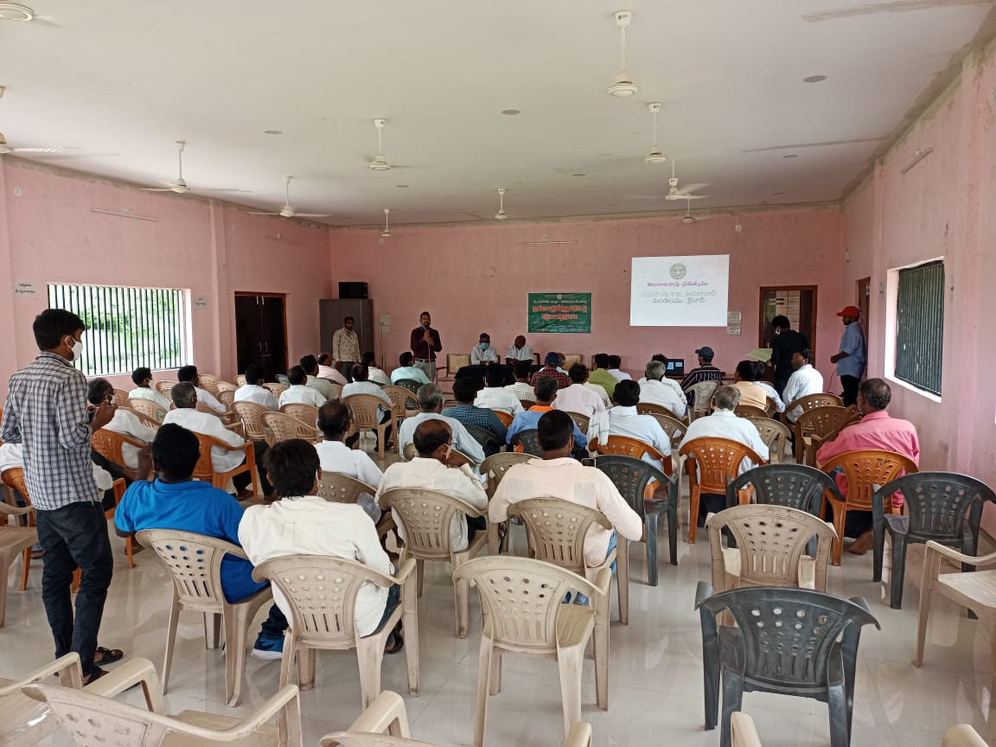

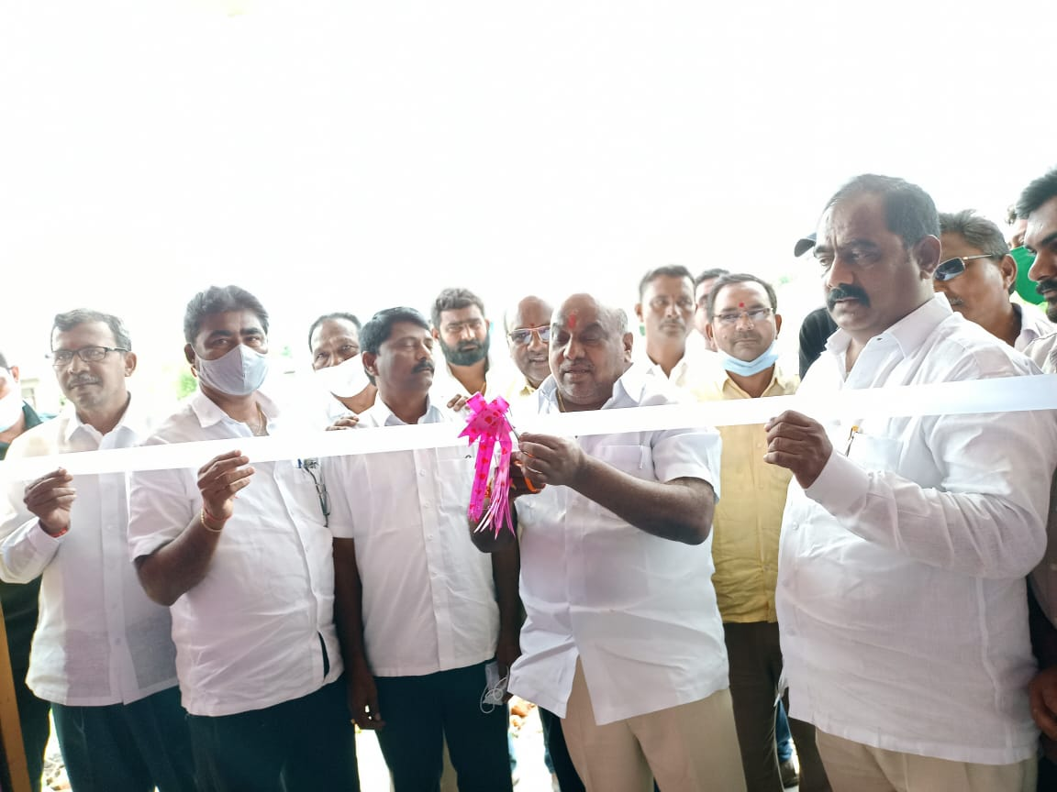

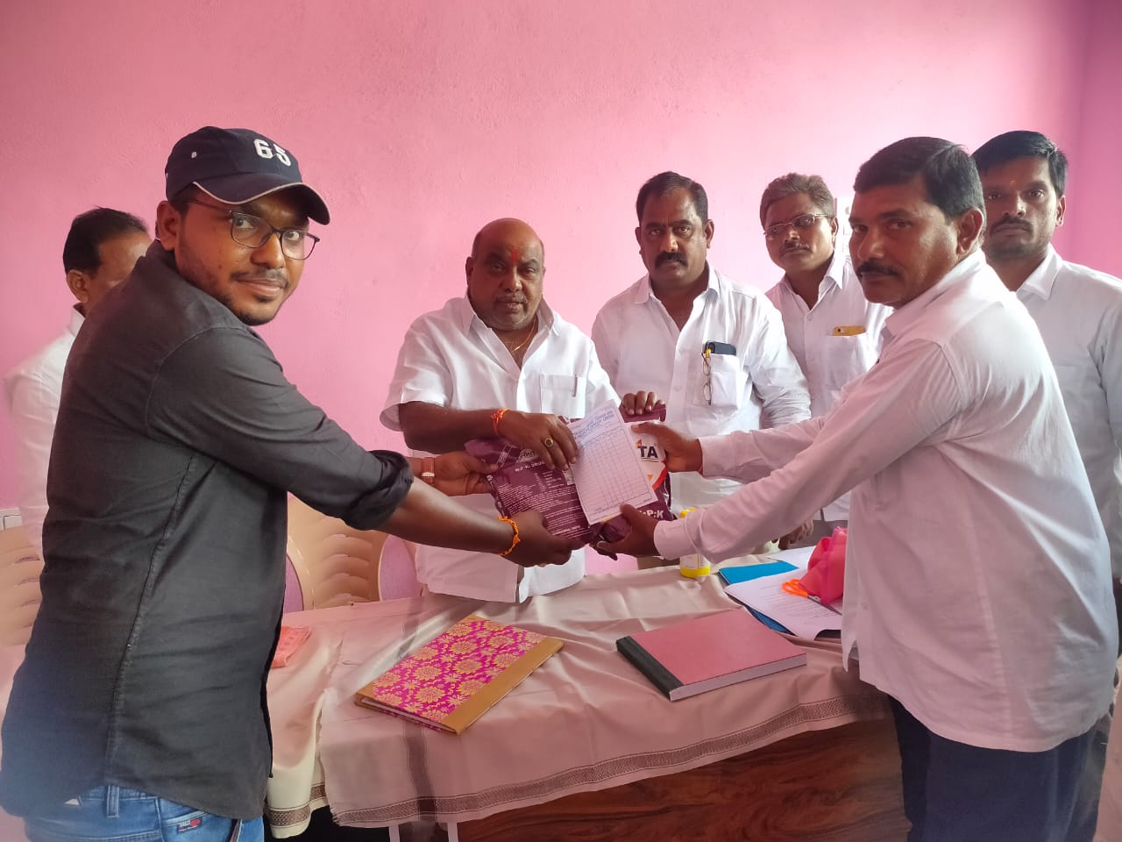

Name and Contact Number
Gaddam Ravinder Reddy: Chairman:9177099939
Nikhil Reddy :CEO : 9381045390
Mr. Ramanjulu :CBBO( Team Leader):6281561094

