LEAF AND BUD ORGANIC TEA FED FARMER PRODUCER COMPANY LIMITED
Leaf and Bud Organic Tea Fed Farmer Producer Company Limited Promoted by Erode Precision Farm Producer Company Limited and NAFED is working with the main Objective to provide farmers with better market linkage. The FPO is situated in ooty block,Nilgiris’
Year of Registration | 2021
State | TAMILNADU
District | THE NILGIRI’S
Block | OOTY
CBBO | ERODE PRECISION FARM PRODUCER COMPANY
Shareholder Farmers (Nos)
 | Small Farmers: 248 Marginal Farmers: 54
 | Women Farmers: 69 Tribal Farmers: 0
State Category | Hilly Area
Share Capital (INR- Lakh) | 6,04,000
Business Activities (Summary) | 6LAKH TURNOVER (TEA BLENDING & MARKETING)
Area of Success*: | SUPPLY OF NON-TOXIC QUALITY PREMIUM TEA
Board of Directors | Male: 6 Female:1

Background
The region is heavily dependent on agriculture with poor infrastructure facilities, middle man involvement, lack of farm produce collectivization, lack of better price realization and challenges in access to market are some of the key challenges. We “LEAF AND BUD ORGANIC TEA FARMER PRODUCER COMPANY LIMITED” Consist of 302 shareholders at three different blocks in Nilgiris and We are doing business based on NON_TOXIC PURE TEA With our own Brand named “KANUSH”.

Focus Areas
Identifying the need for market linkages and better price discovery, the FPC was formed in 2021. FPC has today has increased its outreach to 302 shareholder farmers covering three different Block in NILGIRI’S.
.

Strategic Interventions undertaken
FPC aimed to achieve its objectives by using collectivization techniques and participation of the benefiting community, including rural farmers, and panchayat.
FPC is bringing to its member farmers the benefit of direct procurement of premium tea from TEA BOARD OF INDIA. FPC has developed demand planning and forecasting system under the leadership of BODs
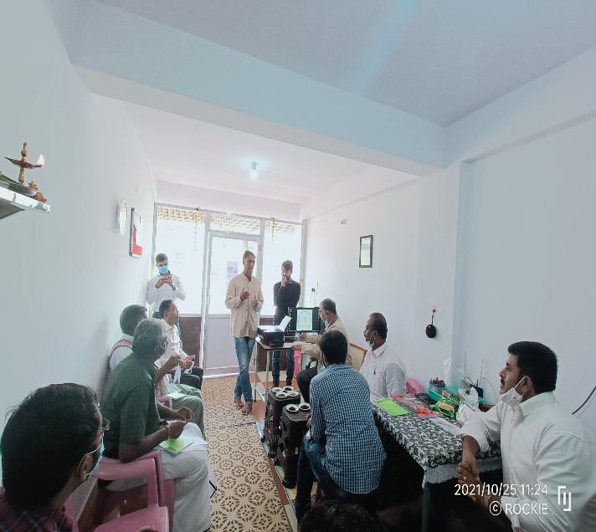

Success Mantra
We are the only FPC to have a Registered Buyer license from TEA BOARD OF INDIA.
Farmers motivated to join FPO to Avoid Middleman and Auction centre to sell their products
FPO-FPO concept explained to farmers
FPC done total business of Rs. 6,00,000lakh within the year of establishment benefiting 302 member farmers.
Through FPC the small tea growers are get better price for their tea leaves
Farmers are circulated for value addition to sell their products at better price

Recognition
FPC has shared the success story in the Regional Conference of FPOs and CBBOs held at Bengaluru to showcase the progress of FPC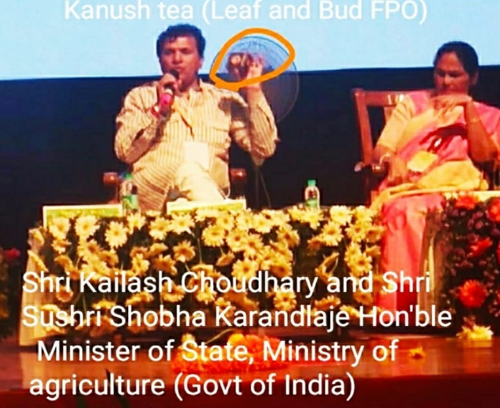

Benefits of the scheme
FPC has availed equity grant of 3 Lakh under the “Central Sector Scheme for Formation and Promotion of 10,000 Farmer Producer Organizations (FPOs)” on 1st January 2022.

Convergence with other Central and State government schemes
FPC has not applied under any scheme till date.

Lessons learnt
Product quality knowledge based on consumer need
Quality upgradation and value addition
GI (Geographical Indications) certification for farmers
Guidelines for Tea Plantation , organic Manure usage ,Tea leaves plucking intervals etc..
.

Way forward
Our FPC have the I/E code (IMPORT/EXPORT) Registration certificate for future TEA Export.
At Future the organization plan to start Mini Tea factories in three blocks for Employment generation
We have seed and fertilizer licence ,So plan to start Seeds & fertilizer units in future

High Quality Images with caption

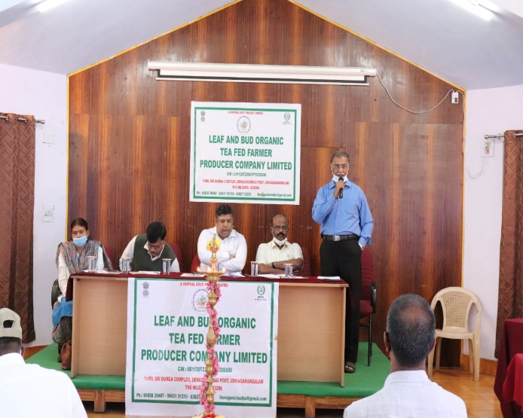

Name and Contact Number
CHAIRMAN : SHANMUGAM -9585839407
CEO : VIGNESH KANNA -9123579841
CBBO :

