JaiHind Madukkarai Coconut Fed. Farmer Producer Company Ltd.
JaiHind Madukkarai Coconut Fed. Farmer Producer Company Limited promoted by NAFED is working with the main objective to provide member farmers with better market access opportunities. The FPO is situated in outskirts of Coimbatore.
Year of Registration | 2021
State | TamilNadu
District | Coimbatore
Block | Madukkarai
CBBO | Erode Precision Farmer Producer Company Ltd.
Share Holder Farmers
Small Farmers: 259
Farmers:309
Women Farmers:50
State Category | Plain Area
Share Capital (INR-Lakh) | 6.18 Lakh
Business Activities (Summary) | Coconut Trading
Area of Success | Root Feeding
Board of Directors | Male- 08 Female-02

Area of Success:
Agriculture specifically coconut farming is the major livelihood of farmer inhabitants of this region. The major setback in the region are poor infrastructure facilities, middle men involvement, lack of collection centres, irregular market pricing. Jaihind Coconut Fed. FPCL deals with Coconut, Tender Coconut, Vegetables and Certain cropping techniques related to Coconut.
Focus Area:
Identifying better market linkages while eliminating middle men and better price, the FPC was formed in 2021. FPO has today increased its outreach to 309 shareholder farmers covering 10 Panchayats.
Strategic Intervention Undertaken:
FPC aimed to achieve its objective by using middle men elimination and improved participation of the farming community.
Success Mantra:
FPC with the support of CBBO has demonstrated the training regarding the modernized techniques in coconut farming and impact of middle men in marketing of produce.
Market intelligence to connect buyers directly to farmers with better price realization
Assured market lineage in helping farmers avoid distress sale in the hand of intermediaries and local market
Increase of farmer income by market support
Benefits of the scheme
FPC has applied for matching equity grant of 6.18 lakhs under the “Central Sector Scheme for Formation and Promotion of 10000 Farmer Producer Organizations (FPO’s)
Convergence with other Central and State Government Schemes
FPC has not applied for any scheme till date.
Lessons Learnt
Farmers if directed to have better access opportunities to market and reduced influence of middlemen will help them scale greater participation for development of Agriculture.
Direct sale of the produce as whole lots to buyers has helped to reduce layers of middlemen involvement thereby increasing the Produce price benefits
Way Forward
The FPC has planned to setup oil crushers and value addition plants in coconut after availing the matching Equity Grant

Image
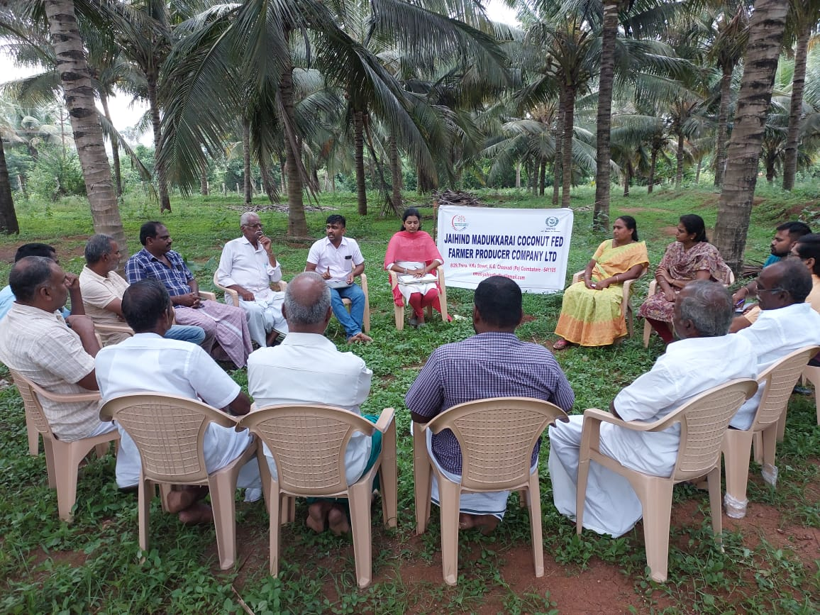
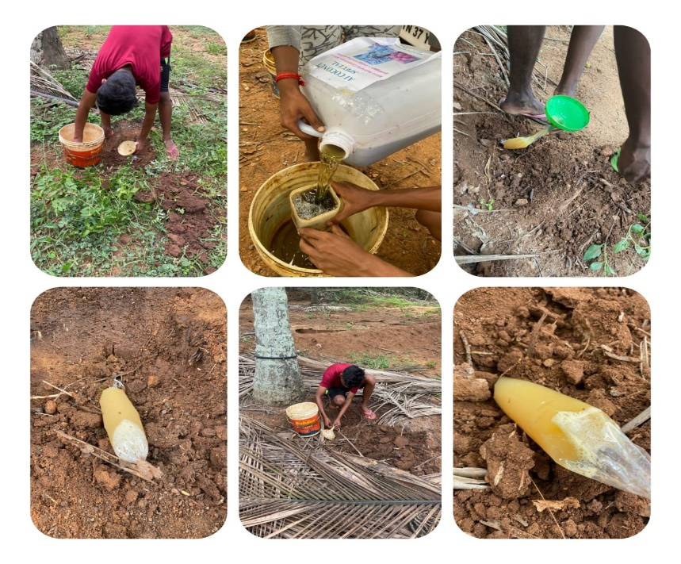
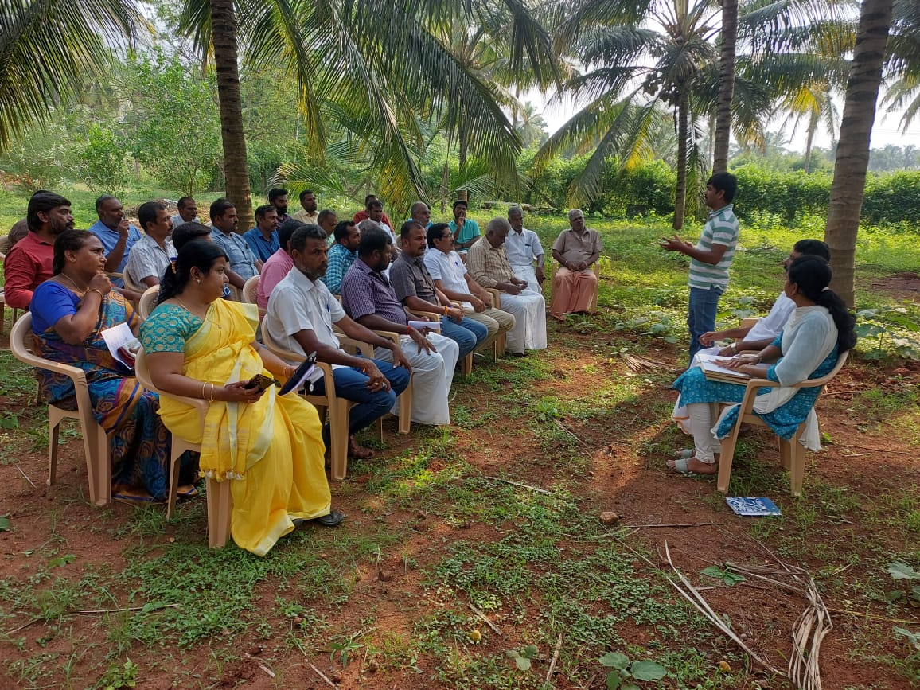

Name and Contact No.
Chairman - P. Senthil Kumar (9597600444)
CEO - Dhivya. A (9942614440)
CBBO Point of Contact- Dr. Vadivel(9443720160)

